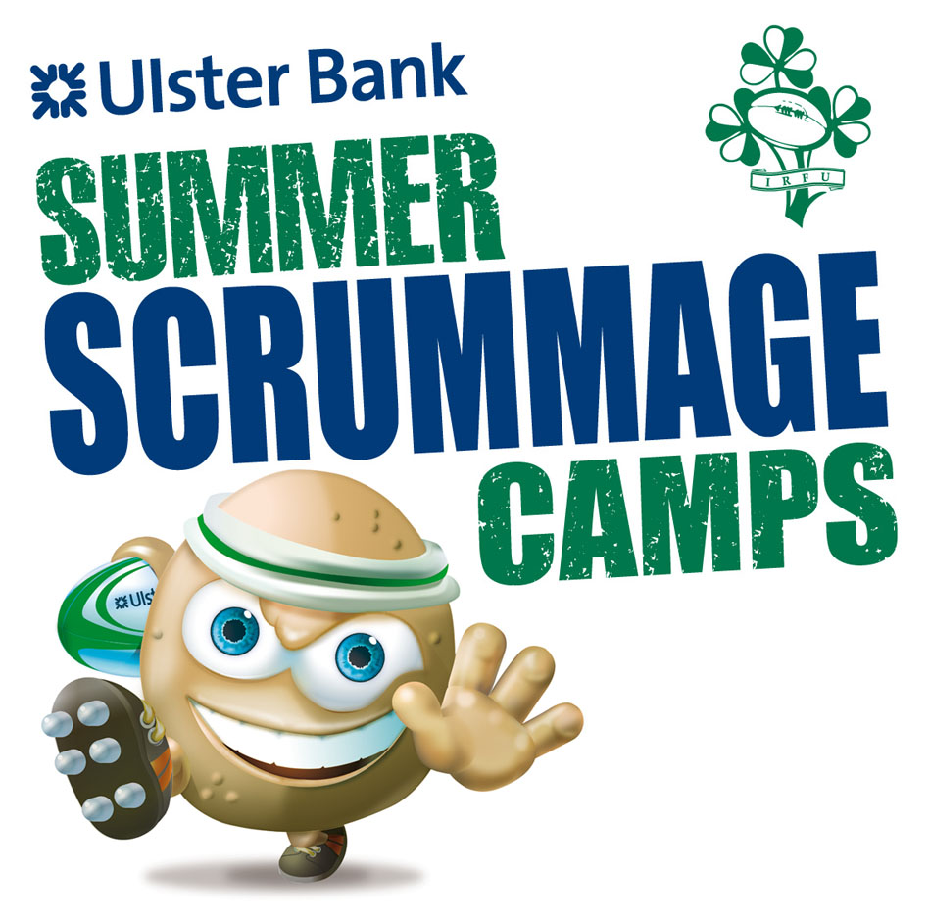
IRFU and Ulster Bank in association with Castlebar RFC are pleased to announce the return of the Official IRFU Summer Camp to Castlebar.
“Through these camps I hope that the rugby stars of the future will begin to develop their rugby skills, learn more about the ethos of rugby, of teamwork, commitment, and above all meet new people and make new friends.”
- Eddie O’Sullivam
Ierland National Team Coach
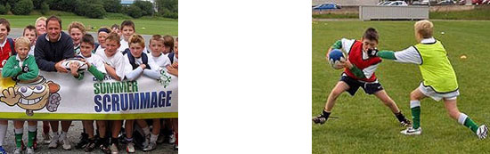
David Humphries visiting camp
The camps, which are for boys and girls from 6 to 13 years of age, are an ideal opportunity for current players to improve skills or for beginners to try rugby in a safe managed environment.

Participants are separated into groups based on age and playing experience. Over the course of the week they will be coached in all the skills of the rugby with these being put into practice in games throughout the day.

As you can see from the pictures all participants are kitted out in the highest quality Canterbury gear comprising of a shirt, shorts, socks, gear bag and rugby ball.

All the coaches on the camp are fully qualified IRFU coaches, having completed courses specific to managing younger children and childcare.

MEET YOUR HEROES
Each camp is attended by players from the Connacht professional team which this year will include international signings Gavin Duffy and Johnny O’Connor
Camp runs from 9:30am to 1:30pm from Monday to Friday
Date: 30th July – 3rd August
Venue: Castlebar RFC

Information: 1890 473807

To Attend complete attached Application Form

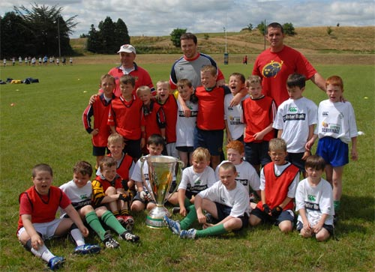
Internationals Marcus Horan and Alan Quinlan bring the European Cup along to the camp

