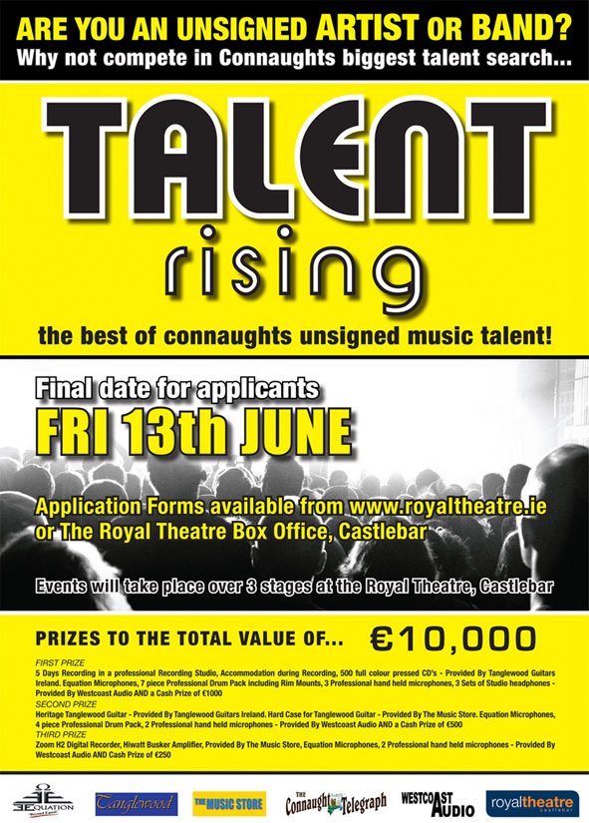

PLEASE PRINT

Name of Act: _______________________________ Town Base: _____________________________

Music Genre: ______________________________ Email: __________________________________

First Contact: ______________________________ Phone Number: __________________________

Second Contact: ____________________________ Phone Number: __________________________

BAND MEMBERS

Name:_______________________________ Age: ____ Instrument/Vocal: _______________________

Name:_______________________________ Age: ____ Instrument/Vocal: _______________________

Name:_______________________________ Age: ____ Instrument/Vocal: _______________________

Name:_______________________________ Age: ____ Instrument/Vocal: _______________________

Name:_______________________________ Age: ____ Instrument/Vocal: _______________________

Name:_______________________________ Age: ____ Instrument/Vocal: _______________________

MUSIC

This competition is created for unsigned musicians: bands and solo musicians.
Participating Acts may perform original music; cover other artists’ material or any combination thereof.
No backing tracks will be permitted in this competition.

SONG TITLE + ARTIST

1: __________________________________________________

Optional Titles (Required if the above are cover versions)

2: ___________________________________________

3: ___________________________________________

4: ___________________________________________

ENTRY FEE’S
€20 entry fee must be paid per member of act.

Entry fees must accompany this application form to be deemed valid. Any application received after the closing date will be returned to sender. Please do not send cash in the post.

Please make cheque’s payable to:

Talent Rising,
The Royal Theatre,
Old Westport Rd,
Castlebar,
Co.Mayo

Alternatively you can call into the Royal Theatre Box Office in person.

ADJUDICATION
The Semi Finals will consist of Six to Eight Acts per event and will be selected from the provisional heats by an anonymous judging panel. Each Act that goes through to the Semi Finals will be announced on the night.
These acts will be judged on the following criteria:
1. Showmanship,
2. Musical Ability,
3. Delivery,
4. Ensemble
5. Professionalism.

The Judges decision is final.
The Semi Finals and Final will have a judging panel, which will account for 50% of the vote. The audience will account the remaining 50% and voting slips will be provided at the entrance to the venue. Strictly one vote per person.

TERMS AND CONDITIONS:

-All Backline equipment (Guitar Amps, Bass Amps, Electric Drum Kits, Mics etc.) will be supplied by the event organizers.
-No backing tracks will be permitted in this competition
-Each Act must bring their guitars, keyboards and/or other relevant instruments for performance in good working order.
-All equipment must be removed from the venue at the end of the evening.
-No extra additions to the drum kit will be permitted at the Heats, until later stages in the competition.
-Applicants must have at least one member residing in Connaught at the time of the competition.
-Sound Check will be prior to the event, and will be limited to one song or less.
-Acts will be limited to a strict stage time of 15 minutes including set up and performance of two songs and take down.
-Acts will be provided with a preparation area off stage before they are called to perform.
-Applicants must be between the ages of 14- 23 on the day of the final event to qualify.
-Any band member who appears to be under the influence of drugs, alcohol or other altering substance at time of performing will be disqualified.
-Any act that is not ready to perform in the assigned time schedule of the event may lose their place with the possibility of being disqualified without refund.
-There will be no guest list. All supporters must pay entry fee on the door.
-The event organizers accept no responsibility for any loss or damage of equipment used during any stage of the competition.
-The performances at the final events may be recorded by the organizers and such recordings shall be the property of the organizers. Each Act performing in the final events is deemed to have granted the organizers a license to use such recordings for any purpose.

Any Act found breaching the terms and conditions will be disqualified without refund.

I/We the undersigned confirm that I/ We have read fully and agree to the terms and conditions of the competition. All members must complete below.

Signed:_________________________________________ Print: _______________________________________

Signed:_________________________________________ Print: _______________________________________

Signed:_________________________________________ Print: _______________________________________

Signed:_________________________________________ Print: _______________________________________

Signed:_________________________________________ Print: _______________________________________

Signed:_________________________________________ Print: _______________________________________

