LEADER4Enterprise
Expression of Interest Form

- All of your information will be treated as confidential –

The aim of this questionnaire is to get some basic information about you and your business. This will help us to determine if South West Mayo Development Company is the best agency to support your project. We will also use this information to see if you would benefit from participation in the LEADER4Enterprise programme.
General Information

How did you hear about today’s launch?

Name:
Business / Organisation Name:
Address:
Tel No. / Mobile No.:
Email:
Website:
You and Your Business
What is your employment status? |  | □ Employed □ Unemployed □ Self Employed □ Farmer
What stage are you at? |  | □ Existing Business □ Interested in Setting up a Business  □ New Business Start Up □ Community Enterprise  □ Other (please specify)___________________
What sector are you in? |  | □ Farming / Agri Tourism / Agri Diversification □ Craft □ Tourism  □ Renewable Energy □ Artisan Food □ Community Enterprise  □ Rural Enterprise / Micro Enterprise □ Service  □ Other (please specify)_______________________________
Do you have an idea for a project or business that you think may be eligible for LEADER grant support? |  | □ Yes, I have an idea but I need help to develop it further  □ No, I need help to develop an idea  □ I am here to hear about the LEADER4Enterprise Programme  □ Other (please specify)_____________________________________
 | 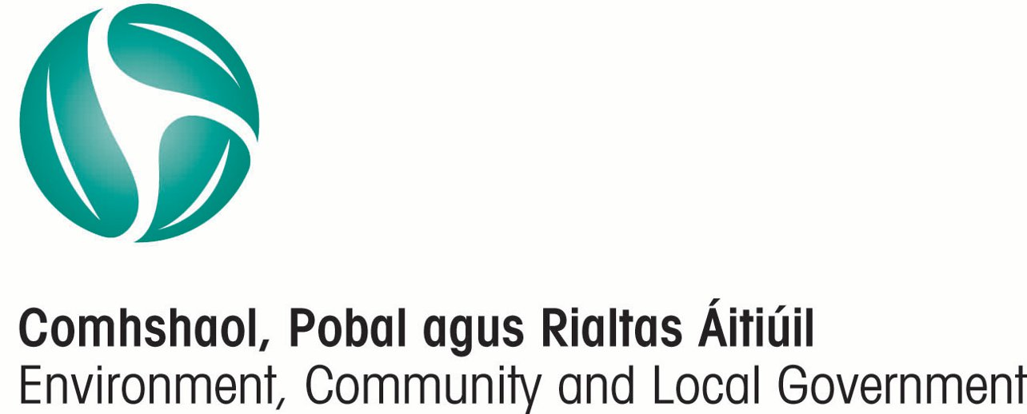 | 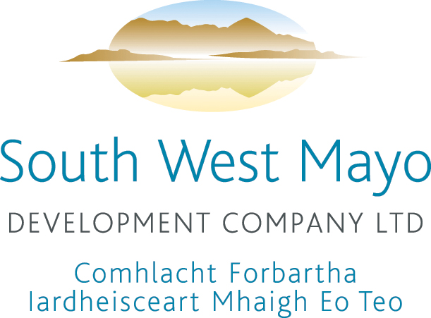 |  | 
Funded by South West Mayo Development Company Maoinithe ag Comhlacht Forbartha Iar-dheisceart
under the Rural Development Programme 2007 – 2013, Mhaigh Eo faoin gClár Forbartha Tuaithe 2007 – 2013,
Irish Government National Development Plan 2007 – 2013 Rialtas na h-Éireann Plean Forbartha Náisiúnta 2007 – 2013

Your Project
Please give a short description of your idea or proposed project:

What work have you done on this project?
What are the estimated project costs? | Estimated Total Costs €____________  Premises ___________ Equipment ___________  Other (please specify) _________________________________
Source of match funding: | □ Own Cash □ Bank Loan  □ Other (please specify): ___________________________________
Project Timescale: | [Months/Years]
Earliest Start Date: | [Month/Year]
Location of project / business:
Site / Premises: | □ Owned □ Leased  □ Other (please specify): _________________________________
Planning Permission: | □ Granted □ Required □ Not Applicable
Have you talked to other agencies?
Have you received funding in the past? | From Who? __________________________________________  When? ___________ How Much? €___________
What areas do you need help with? | □ Knowing whether the idea or project is worth pursuing further  □ Researching the market, knowing who my customers are, where to find them, understanding why they would buy my product or service  □ Developing a plan for the business  □ Pricing, Costs, Forecasts and Budgets  □ Sales & Marketing  □ Applying for Grant Aid  □ Getting Matching Funding  □ Other (please specify)________________________________
What is your business / project experience? | □ Own existing business 3 yrs+ □ Own existing business less than 3 yrs  □ Starting a business for the first time  □ Previous experience managing a business  □ Some limited business experience  □ Previous experience in grant application for community projects  □ Other (please specify)_____________________________________
Please return this expression of interest form and any additional information to:
LEADER4Enterprise, South West Mayo Development Company, Georges Street, Newport, Co. Mayo
Call Us: 098 41 950 E-mail Us: leader4enterprise@gmail.com
Note: To be considered for participation in the LEADER4Enterprise programme you must submit a Expression of Interest form no later than 30th Nov 2012

DATA PROTECTION

South West Mayo Development Company is registered with the Office of the Data Protection Commissioner. Under the terms of the data protection act, the company must ensure that all personal data held, is obtained and processed fairly, kept for specific and lawful purposes, processed only in ways compatible with the purposes for which it was given to us initially, kept safe and secure, is accurate and up-to-date, is adequate, relevant and not excessive and retained for not longer than necessary.

When you contact or provide information to South West Mayo Development Company we will create a computer record in your name. Information that we assemble, pertinent to the application, including information that you give us, is added to the record. You have the right, given by the Data Protection Act 1988 and the Data Protection (Amendment) Act 2003 to obtain a print out of your computer record at any time. We charge a fee of €20.00 for each request.

The information we record is used only for the following purposes:
- Processing and evaluating applications.
- Analysing applicant information for other bodies such as Government Departments.
- Publication of the company’s activities.

Personal information about you will be disclosed only in accordance with our registration under the Data Protection Acts. The purpose for which we hold information and the people and bodies to whom we may disclose it are listed in the Register of Data Controllers, kept by the Office of the Data Commissioner at Canal House, Station Road, Portarlington, Co. Laois. (email info@dataprotection.ie) You may inspect it free of charge.

I confirm that I have read the above and I consent to the use and disclosure of data information as outlined therein.

Signed:

Date:

