EURO TRAINING WORKSHOP

Castlebar Chamber of Commerce
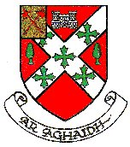

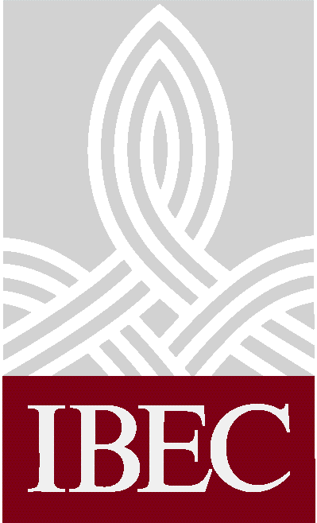

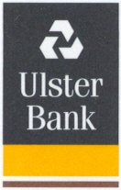

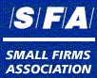
€
€
in association with
IBEC, Small Firms Association,
Ulster Bank and Forfás
This Euro training workshop will provide hands-on
assistance to companies to tackle the essential tasks
they must undertake by year end.
The workshops will be conducted by experts from
IBEC, Ulster Bank and Forfás.

In
Breaffy House Hotel
Wednesday 28th November at 7:30pm (duration 2.5hrs approx.)
Cost: £25 per participant
EVENT FORMAT

Introductory Sessions : General euro issues, Banking issues, Legal matters

Tea/Coffee Break
Workshop A Retail: Dual currency handling issues, Cash requirements, Dual pricing & Codes of Practice, Security, Conversion exercises, Till exercises with notes & coins, - Equipment

Workshop B Small Firms: Accounting issues, Software packages, Tax returns, Cross border payments, Strategy implications

-------------------------------------------------------------------------------
BOOKING FORM

PLACES LIMITED - Please book early
Participant Names ______________________________ _________________________________ ________________________ ________________________________ ___________________________________ Please Reserve ______________ places Workshop Preference (please tick) Retail Small Firm
Name of Company________________________________________ Telephone_______________________________
Member/Customer of (please tick) Chamber of Commerce Ulster Bank Other
Please return booking form and payment to: Castlebar Chamber of Commerce, Spencer St., Castlebar
Telephone: 094 24845 Facsimile: 094 24971 E-mail: chamber@castlebar.ie

